Sponsored by Bill Reading

STEWARTRY
BOWLING ASSOCIATION

TOP TEN FINAL

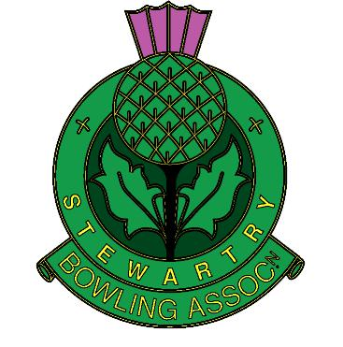

GATEHOUSE

Vs

NEW ABBEY

AT

SPALDING

BOWLING CLUB

ON

Friday 2nd June 2006

President - Hamish Sinclair

The Trophy Shop

Dumfries

Umpire – William Thomson

Thanks to Spalding Bowling Club
For the use of their Green and facilities.

NEW ABBEY
RED DISKS

SINGLES - Keith Shuttleworth 21

PAIRS - Les Shuttleworth 9
Neil Shuttleworth

TRIPLES - David Gibson 12
William Bryden
William Mair

FOURS - Ian Shuttleworth 20
Jim Clingan
John Bigham
Alex Gibson

GATEHOUSE
BLUE DISKS

SINGLES - Andy McMinn 9

PAIRS - Derek Rogerson 23
David Kiltie

TRIPLES - Tom Kirkpatrick 6
James Cruickshanks Jr
Robert Watson

FOURS - Harry McLeod 6
Tom Rogers
Charlie Pickthall
Gordon Cochrane

